Project Report
For
CS483 – Data Mining and Pattern Recognition Spring, 2015
Computer Science Department
California State University, Fullerton

Handwritten Character Recognition System
Jai Inamdar
Mihir Thuse
Purva Chakravarti
05/07/2015



Contents
Sr. No. | Particulars | Page No.
1 | Introduction | 1
2 | Feature Selection & Extraction | 2
3 | Classifier Design & Study | 3
4 | Testing Results & Discussion | 5
5 | Summary | 8
6 | Acknowledgements | 9
7 | References | 10

Introduction

Character recognition is the process to classify the input character according to the predefine character class. With increasing the interest of computer applications, modern society needs the handwritten text into computer readable form. This research is a simple approach to implement that dream as the initial step to convert the handwritten text into computer readable form. Some research for hand written characters are already done by researchers with artificial neural networks. In this paper we use Kohonen Self Organization map. A network, by its self-organizing properties, is able to infer relationships and learn more as more inputs are presented to it. One advantage to this scheme is that we can expect the system the change with changing condition and inputs. The system consistently learns. Moreover the recognition ratio is excellent in the proposed system. According to the nature of the pattern to be recognized, recognition may be divided into two major types: the recognition of concrete items and recognition of abstract items. . However in many applications, it should be more beneficial if the network is trained form its own classification of the training data. To do this two basic assumptions about the network are made. The first is that class membership is broadly define as input patterns that share common features, the other is that the network will be able to identify common features across the range of input patterns. Kohonen’s self-organizing map is one such network that works upon this assumption, and use unsupervised learning to modify the internal state of the networks to model the features found in the training data.

The system overview: The overall method of the implemented system is illustrated in figure-1
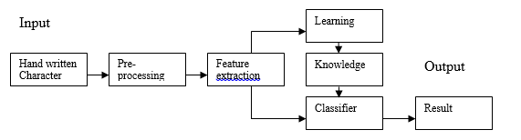

Figure-1: Overall model of implemented system

Preprocessing & Feature Selection

The input to the recognition system is acquired by scanning a plain paper containing character either handwritten or printed. The scanned paper is then saved as an image file (.BMP). Ignoring the concept of colored paper or character, the black part of the image is considered as the character and the white part is considered as the paper.

Feature extraction is the process of extracting essential information contain from the image segment containing a character. It plays a vital role in the whole recognition process. This effectively reduces the number of computation and hence reduce the learning time in the training session of the neural network and faster the recognition process. In this section each handwritten character is converted to a real valued vector form of 0s and 1s that characterizes the essential information contain of the input pattern. The 0s corresponds to white pixels while 1s is corresponds to black pixels. To achieve this an M×N image is reduce to a (M/R₁)×(N/R₂) (here 16×16) size image with the reduction factor R1 across height and R2 across width. The cell value of the reduce picture is calculated using R₁×R₂ window and calculating the number of black pixels within each window. If the number of black pixels is more than or equal to 50% of the total number of pixels in that window, the cell value is considered as 1 otherwise the cell value is considered as 0. The algorithm for this conversion is presented as given

- for I =1 to M/R₁
- for j = 1 to N/R₂
- BEGIN
- BlackPixelCount = 0.0
- for k= (I-1)* R₁ to I*R₁
- for L= (j-1)*R₂ to j*R₂
- BEGIN
- if (ReadPixel(k,L)= BlackPixel) then
- BlackPixelCount= BlackPxilCount+1
- END
- if (BlackPixelCount / (R₁*R₂)>=0.5) then
- FeatureMat (I,j) = 1
- else
- FeatureMat(I,j)= 0
- END

Classifier Design & Study

The Kohonen network has two layers, an input layer and a Kohonen out layer. The input layer is a size determined by the user and much match the size of each row (pattern) in the input data file. A typical Kohonen network is illustrated in figure-2. A Kohonen feature map may be used by itself or as a layer of another neural network. A Kohonen layer is composed of neurons that compete with each other. The Kohonen SOM use winner take all strategy. Inputs are feed into each of the neurons in the Kohonen layer (from the input layer). Each neuron determines its output according to a weighted sum formula: Output = ∑ w_{ij} x_{j.} The weights and the inputs are usually normalized which mean that the magnitude of the weight and input vectors are set equal to one. The neuron with the largest output is winner. The neuron has a final output of 1. All other neurons in the layer have an output of zero. Different input patterns end up with firing different wining neurons. Similar or identical input patterns classify to the same output neuron. Only winning neurons and their neighbors participate in learning for a given input pattern.
Input Layer
Kohonen Winner
Layer
1
0
0
0
0
0

A Kohonen Network

Training Law for The Kohonen Map: The training law for the Kohonen feature map is straightforward. The change in the weight vector for a given output neuron is a gain constant, alpha, multiplied by the difference between the input vector and the old weight vector:
W_{new}=W_{old}+alpha*(Input-W_{old})
Both the old weight vector and the input vector are normalized to unit length. Alpha is a gain constant between 0 and 1. Let us consider the case of a two dimensional input vector, the effect of the training law is try to align the weight vector and the input vector. Each patterns to nudge the weight vector closer by a fraction determined by alpha. It is not necessarily ideal to have perfect alignment of the input and weight vectors. We use neural networks for their ability to recognize patterns, but also to generalize the input data sets. By aligning all input vectors to the corresponding winner weight vectors we essentially memorizing the input data set classes. It may be more desirable to come close, so that noisy or incomplete inputs may still trigger the correct classification.

Testing Results & Discussion

The design data basically consists of all the 26 alphabets. Each letter has a unique string of 48 numbers in binary format. The test data typically looks like this –

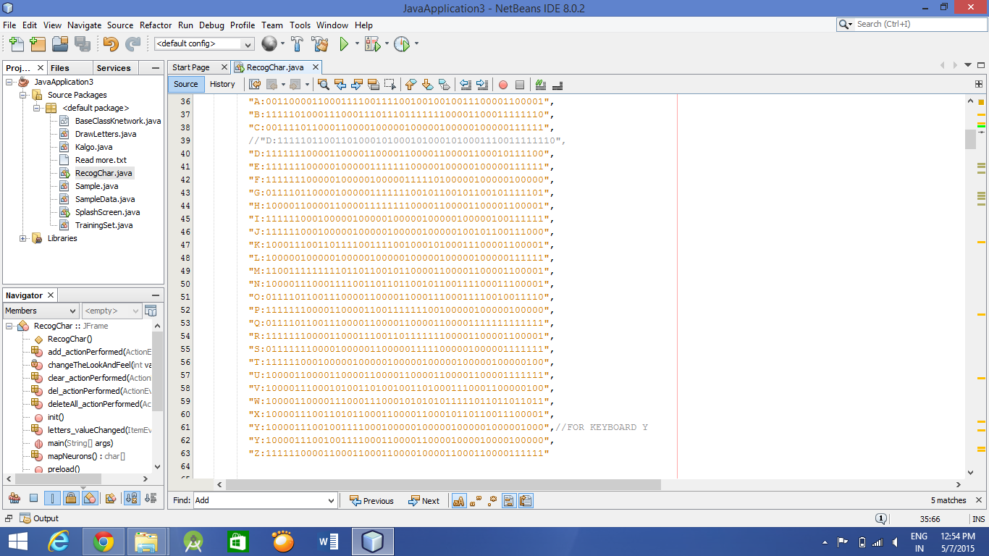

These 48 binary digits occupy themselves in the 6x8 design data matrix.
The test data is the input given by the user using the mouse cursor. The design data appears like this –

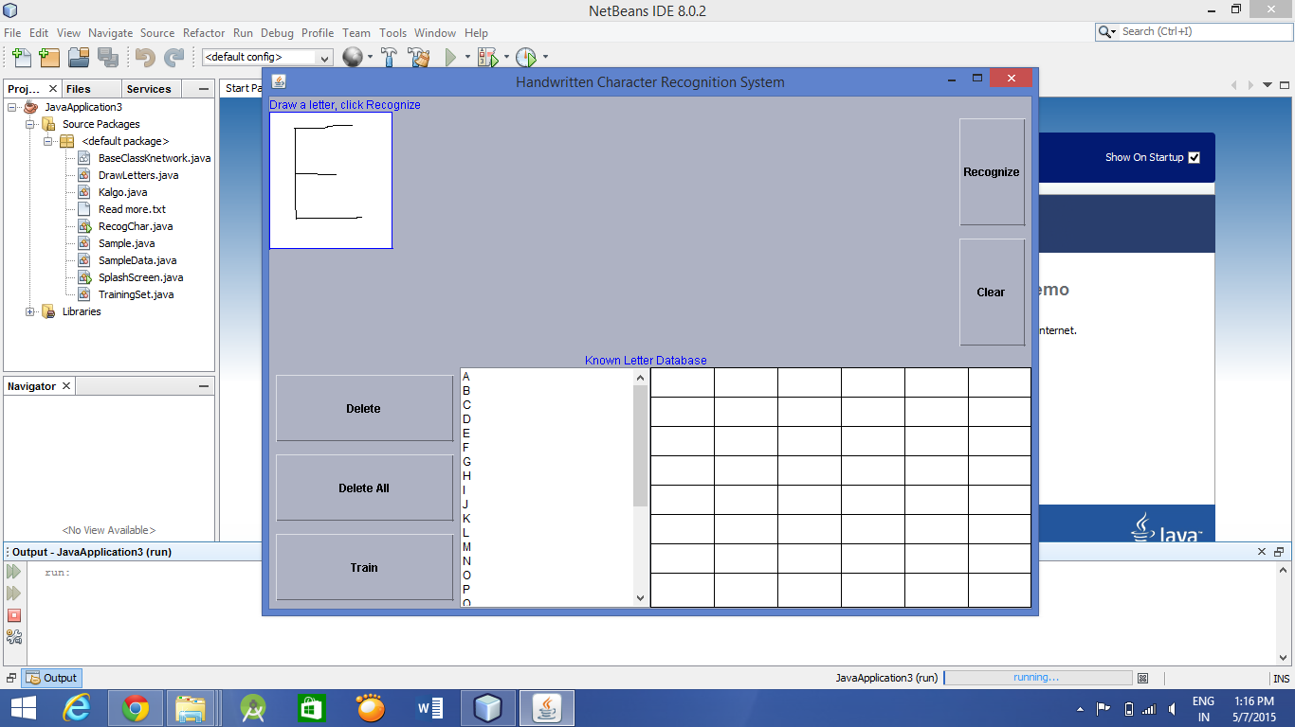
In this case the input is the character E. Based on the design data and test data values, the system trains itself for it to identify the character correctly when entered the next time.

Testing and Results:

Step 1: First we choose a letter from the database

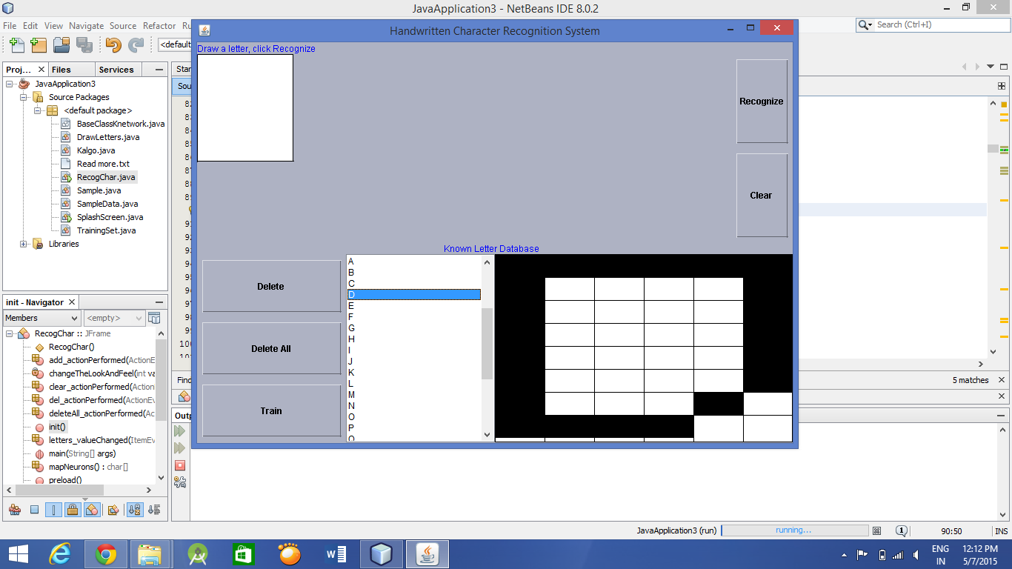

Step 2: Then we click on Train to train the system with the chosen letter

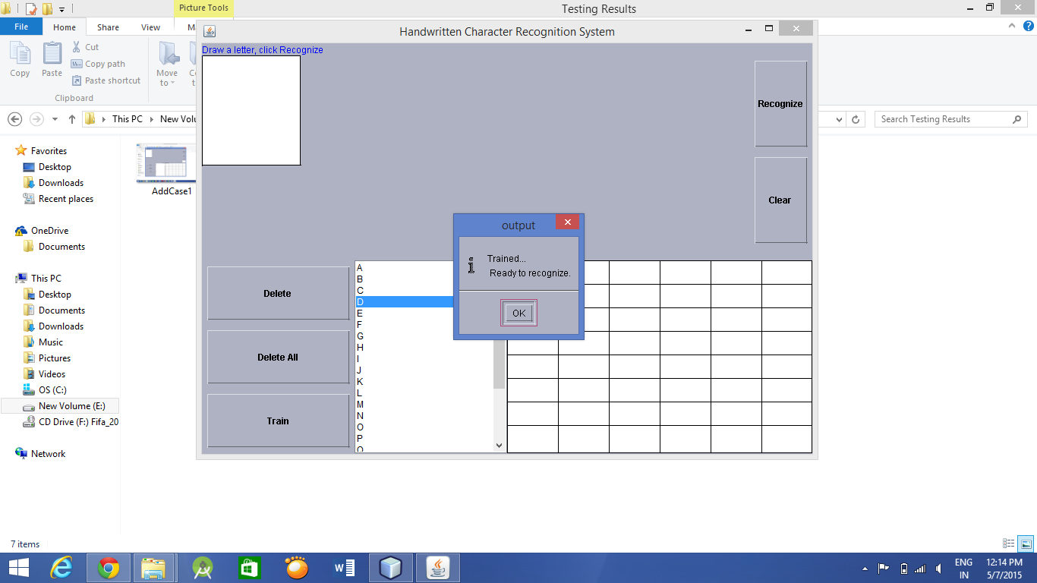
Step 3: Then we draw the letter and click on Recognize. And it shows us the recognized
output.

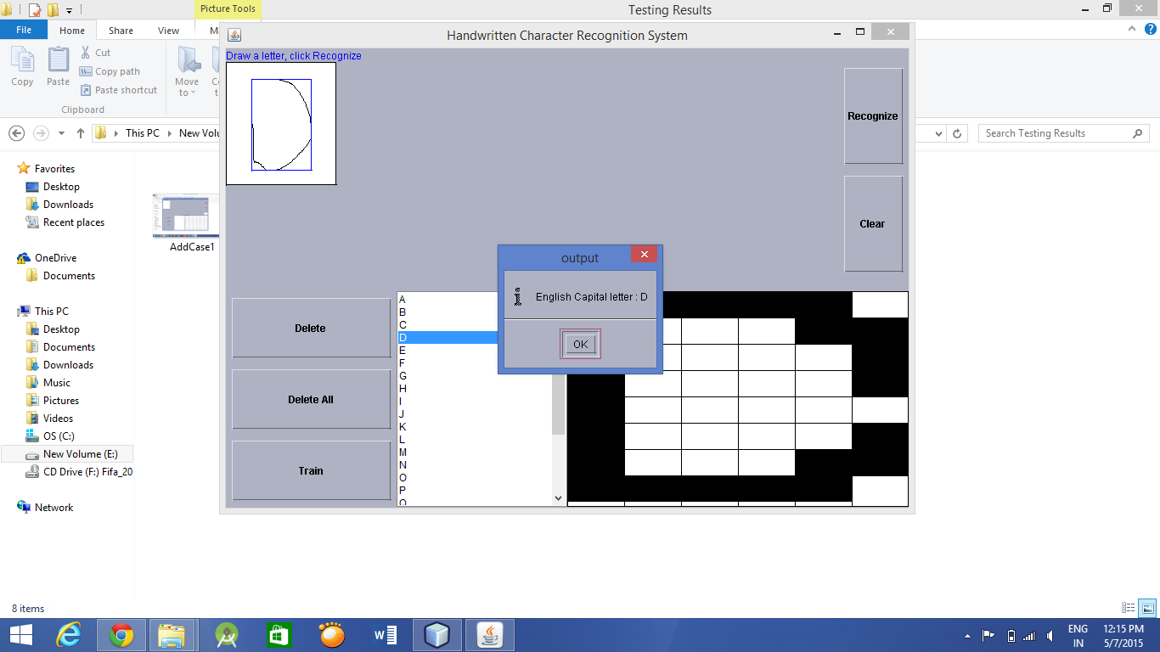

The results clearly showed us the need to give maximum training to the system. The results also indicated us that the system’s accuracy is directly proportional to the number of times it is trained for a specific character.

Discussions:

Prior to starting the project development, we had elaborate discussions regarding which programming language would be best suited to develop the system. Taking into consideration the project requirements with respect to the algorithm and classifier used, user interface and flexibility, we decided to use JAVA for algorithm code and JAVA Swings for the user interface.

Summary

In this project, we attempted to create a system that would recognize handwritten characters using a Kohonen neural network for a classifier. Starting with a raw image of a handwritten image, we preprocessed the image into a 16x16 reduced image that we could use to extract meaningful information. Our chosen features included the number of 1's in each image quadrant, as well as the number of 1's in the upper and lower halves of the image. We chose these features because we felt that they were the ones that uniquely represented each character. Finally, for our classifier, we used Kohonen neural network provided in the JAVA Kohonen Neural Network library. This library saved us a lot of work in the design and implementation of our classifier.

Acknowledgements

We would like to take this opportunity to thank Prof. Peter Lo for being so helpful and understanding. He always made it a point to extend his helping hand which is exactly what was needed for the type of subject of ‘Data Mining and Pattern Recognition’. We would also like to thank our references from which we took help in developing and deploying the project.

References
Handwriting Recognition Wiki: http://en.wikipedia.org/wiki/Handwriting_recognition
JAVA Kohonen Neural Network library: http://jknnl.sourceforge.net/
Introduction to Neural Networks for Java, 2nd Edition by Jeff Heaton
Programming Neural Networks in JAVA Tutorial, Gunadarma University

